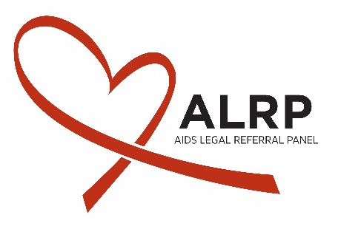
Job Description
Fall Law Clerk

About ALRP
Founded in 1983, the AIDS Legal Referral Panel (ALRP) provides free and sliding-scale legal assistance to people with HIV/AIDS in the San Francisco Bay Area. Originally formed as a resource for those dying of AIDS to receive emergency wills and powers of attorney, ALRP has grown to provide legal services in many areas of civil law. Whether fighting to prevent eviction, advocating against employment discrimination, or working in countless other ways to ensure the legal rights of the HIV/AIDS community, ALRP is committed to providing the most needed legal services to those who most need legal help.
About the Position
The Fall Law Clerk position at ALRP is a part-time (minimum 12 hours/week), unpaid, position. The dates of the clerkship are flexible, but would run from August 2018 until December 2018. Law clerks work with the Client Services staff and ALRP’s panel of volunteer attorneys to facilitate solutions to ALRP clients’ legal problems. Without the dedicated work of law clerks, ALRP would not be able to serve all the clients who call us for assistance. Under the supervision of an ALRP staff attorney, law clerks conduct client intake interviews, assist clients with short-term legal assistance, engage in eviction-defense litigation, and refer complex cases out to ALRP volunteer panel attorneys. Six positions are available for Fall 2018.
Responsibilities
- Perform direct client services—conduct client interviews, respond to general telephone inquiries, provide consultation & advocacy, and make referrals— in many areas of law
- Assist with eviction defense litigation, including discovery, motions, and court appearances
- Diligently record client interviews and case narratives in Access database
- Participate in legal clinics
- Participate in bimonthly Client Services meetings
- Participate occasionally in ALRP events, such as fundraisers and mailing parties
- Perform legal writing and research

Desired Qualifications
- Interest in working with extremely low-income clients with disabilities
- Developed interpersonal communication skills
- Experience with Microsoft Office, especially Access, Word, and Excel
- Ability to learn and implement new skills quickly
- Strong writing skills
- General administrative experience and skills
- Ability to maintain client confidentiality
- General knowledge about HIV/AIDS and LGBT legal issues
- Desire to be a part of a diverse team of individuals
- Bilingual/bicultural applicants strongly preferred
Compensation
This is an unpaid position. ALRP is happy to work with Law Students and Law Schools to secure course credit for the clerkship.
How to Apply
Send a resume and cover letter to Managing Attorney Jaime Rush: jaime@alrp.org
Mailing address: Jaime Rush, AIDS Legal Referral Panel, 1663 Mission Street, Suite 500, San Francisco, CA 94103

